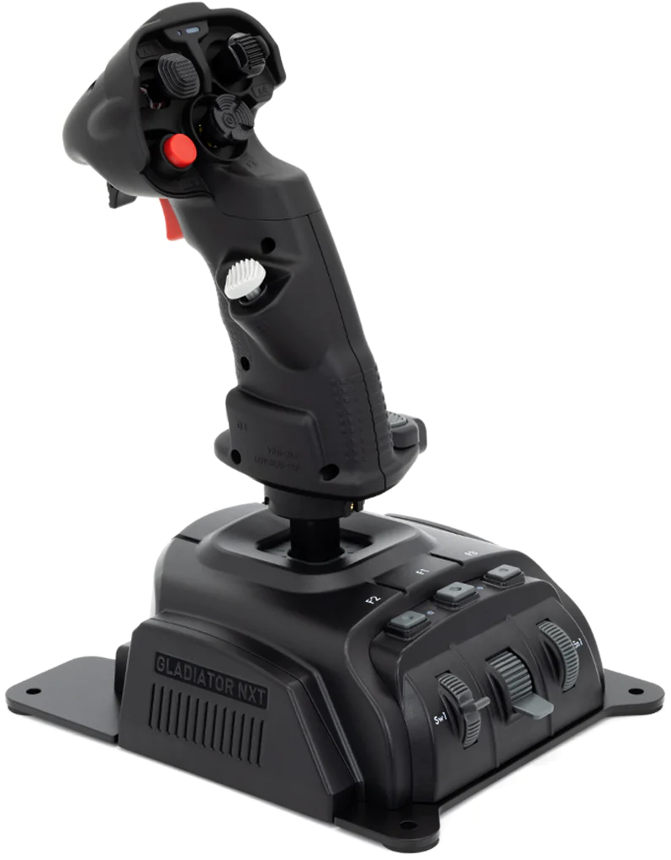
105 - Controls - WSO - Joystick (Right Hand Controller)
U=Up, D=Down, F=Forward, B=Backward, L=Left, R=Right, P=Press, S-*=Shift-*, L-*=Long-*

Trigger -- "Trigger" (RHC)
 | TPOD | HRM | A/A radar | RBM/BCN | TSD | A/G weapon
P1: | Track/Untrack | Expand enable; PPI range change enable | Elevation slew enable | Elevation slew enable; PPI range change enable | Track/Untrack | Track command
P2: | Designation/Cue/Update | Designation/Cue/Update | Target designation | Designation/Map/Cue/Update | Cue command | Track command
Flip-down Trigger
- P: --
Red Button -- "Weapon release button" (Stick)
- P: Weapon release (everything except gun; cannot shoot gun from back seat)
- S-P (3x): Eject
Upper Gray Button
- P: Center VR view
Lower Gray Button -- "Laser Fire Button" (RHC)
- P: Laser Fire Button
Trim Hat -- TDC
- U/D/L/R: Slew TDC cursor
- P: Expand (and designate??)
Dish Hat -- "Castle Switch" (RHC)
 | TPOD | A/G radar RBM | BCN | Set | TSD | A/A radar | A/G weapon
F: | Cursor blank | Cursor MAP | Cursor map | -- | Decrease map scale | MRM search mode | TODO
B: | Target | Cursor TGT | Target | Target | Increase map scale | SRM search mode | TODO
L: | Cursor cue | Cursor CUE/MARK | -- | Cue | Toggles radar/FLIR cue | Undesignate | TODO
R: | Cursor update | Cursor UPDT | -- | Cursor update | -- | Missile reject | TODO
P: | Sequence point select | Cycle SP (steerpoint) | Sequence point select | Sequence point select | Sequence point select | Quick step (returns TDC cursor to STT) | TODO
Dome Hat -- "Coolie"
- U: Scroll right inboard MFD page (3rd MFD)
- D: Scroll right outboard MFD page (4th MFD)
- L: Take command right inboard MFD (3rd MFD)
- R: Take command right outboard MFD (4th MFD
MANVR/PC hat -- Mouse and zoom
Index Finger Hat -- View and Game controls
- F: F6 Weapon view S-F: Active pause
- B: F2 External view S-B: Info bar view toggle
- U: F1 Cockpit view S-U: Rearm/Refuel window
- D: F10 Map view S-D: Show controls indicator
- P: Toggle show control stick S-P: Toggle show pilot body
Gray Side Hat -- "Auto Acquisition Switch aka Mode Reject/FOV" (RHC)
 | TPOD | A/G radar RBM | A/A radar | TSD | A/G weapon
F: | Narrow/Wide FOV | Smaller window/range | High data rate TWS/RAM | Smaller cue footprint | TODO
P: | Undesignate | Mode reject; PSL/Undesignate | Mode reject | Return to P.P. (present position) map | TODO
B: | Return to cue | Larger window/range | Normal TWS | Larger cue footprint | TODO
-- Interrogate/NTTR switch
Real | Sim
F | R | IFF interrogate
B | L | EWWS and NCTR activate

Pinky button -- "Laser Fire Button"
- P: Laser fire button

